**Experiment Name :** Write a Matlab program to show procedure of double side band suppressed carrier modulation

**Objective:**

Objective is to learn how a perform double side band suppressed carrier modulation

**Code :**

clc

clear all

msa = input ('enter message amplitude ');

csa = input ('enter carrier amplitude ');

fm = input ('enter message frequency ');

fc = input ('enter carrier frequency ');

m = msa/csa ;

t = 0:0.001:1 ;

w1 = (2 * pi * fm * t) ;

w2 = ( 2 * pi * fc * t ) ;

ms = msa * sin (w1); % message signal

%plotting message signal

subplot(3,1,1);

plot(t,ms);

%plotting carrier signal

cs = sin (w2);

subplot(3,1,2);

plot(t,cs);

%--------------------------------

dsbsc = csa * m.* sin(w1).*sin( w2);

subplot(3,1,3);

plot(t,dsbsc);

**Output :**

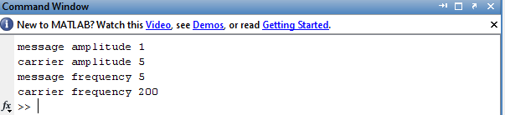

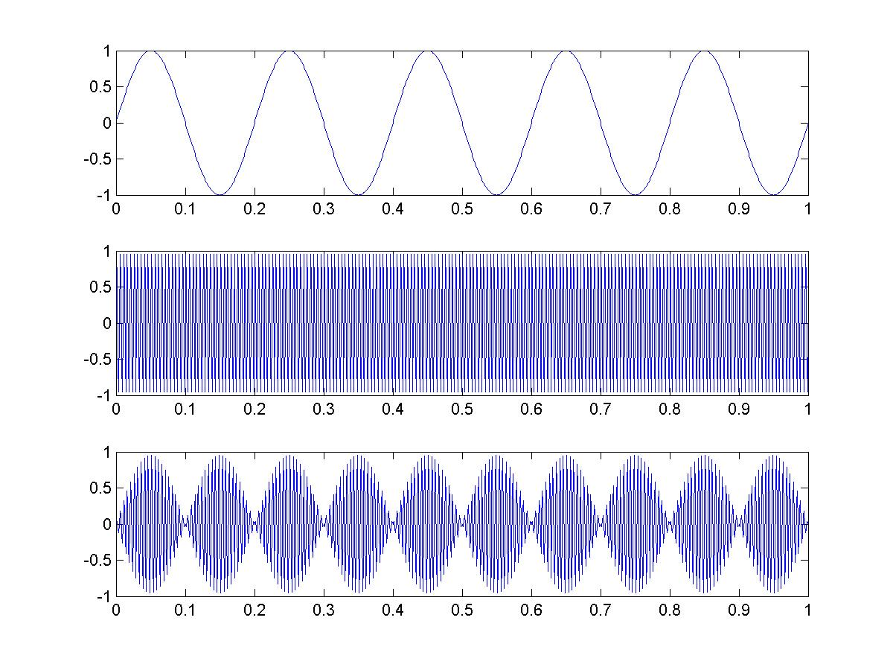

**Conclusion :**

In this lab we learnt how to perform double side band suppressed carrier modulation . We added carrier signal and then noise to the signal after that we demodulated the signal again , this will be of great help in future work .